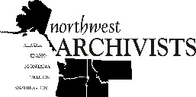 | Northwest Archivists

APPLICATION FORM: NWA Continuing Education Fund

Principal Coordinator Information
Full Name:
 | Last |  | First
Address:
 | Street Address |  | Office/Unit #
 | City | State | ZIP Code
Email: |  | Phone:

Other coordinators:

Project Proposal

Name of Project:

Proposed Location of Activity:

Amount Requested:

Proposed Use of Funds (describes the proposed activities in detail including anticipated audience)
Click here to enter text.

Anticipated Date(s) of Activity:

Attachments
- Budget Estimate (describe expenditures and, when applicable, which costs award will mitigate)
- Support Materials (could include letters of support, signatures of interest, or any documentation you believe supports your proposal)

